**GIT Installation and Setup**

1. Setup an account on <https://www.github.com> with
   1. Username
   2. Email
   3. Enable 2FA i.e Two Factor Authentication

Login to your GitHub account then go to **Settings** 🡪 **Security** 🡪 turn on **Two-factor authentication**

**Note: For Git Hub Test and Git Hub Enterprise environments, Login with LDAP credentials. Step 1 is not required.**

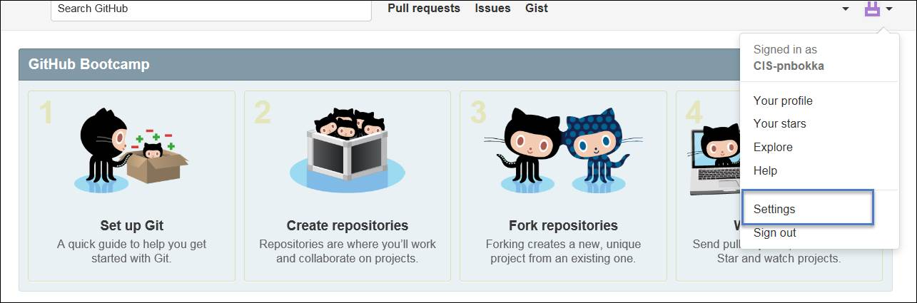

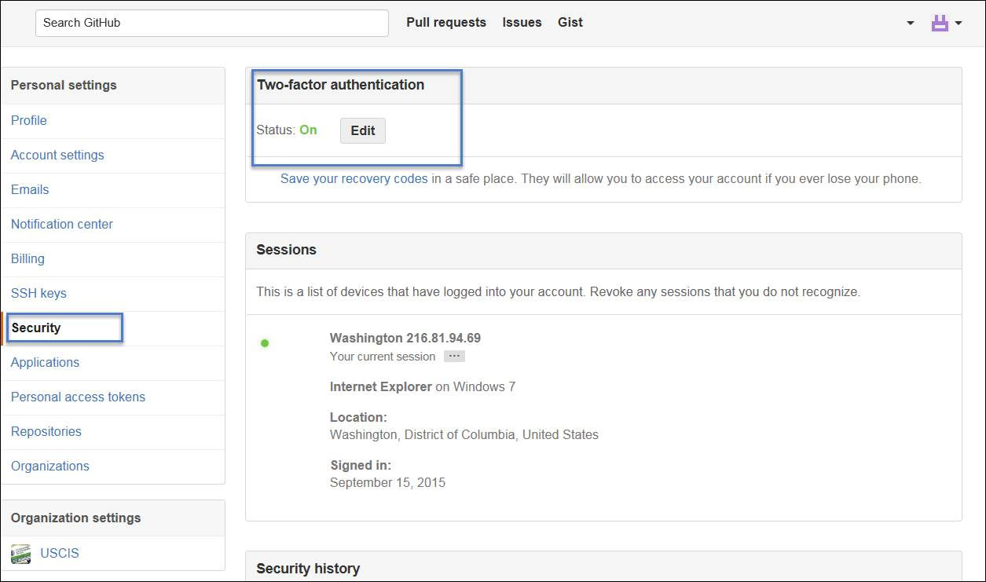

**Download Software**

1. Download TortoiseGit (TortoiseGit-1.8.15.0-64bit.msi) from Serena.
2. Download Git for Windows (Git-2.5.0-64-bit.exe).
3. Download Git Lfs.

**Installation**

Logoff and log back in to GFE with workstation admin account.

**TortoiseGit installation**

Accept all defaults

1. Click Next on Welcome page.
2. Click Next on Information page.
3. Accept defaults on Custom Setup and click Next.

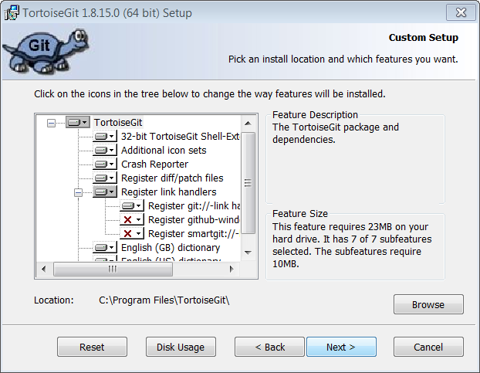

1. Click Install on the next page and
2. Complete setup wizard and Finish.

**Git for Windows Installation**

1. Starting installation opens up Git Setup Wizard and click Next.

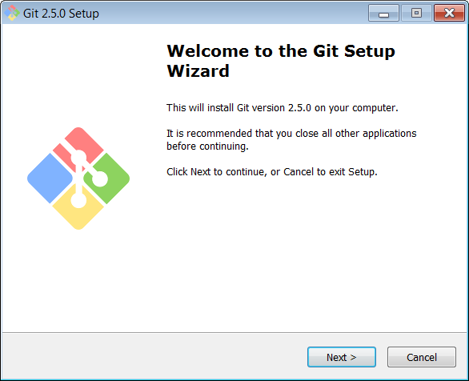

1. Click Next on Information page.
2. Select Destination Location Step is important. Git should be installed in C:\Program Files\Git path only. You have to log in as workstation admin on your laptop to install in “Program Files” folder on your GFE otherwise need open a ticket with helpdesk.

Accept the defaults and click Next.

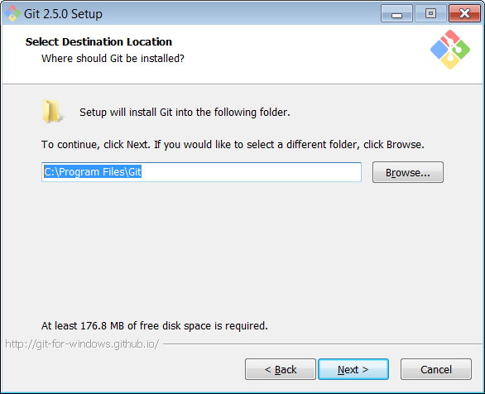

1. Select Additional Icons in Select Components. Click Next.

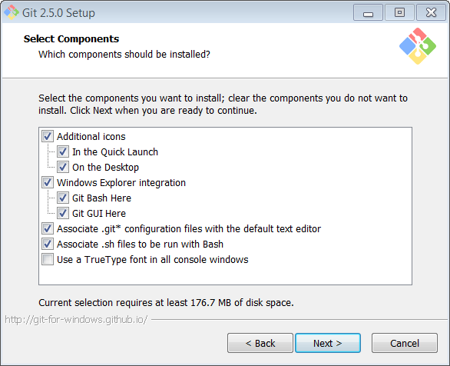

1. Accept Defaults from next screens and complete installation.

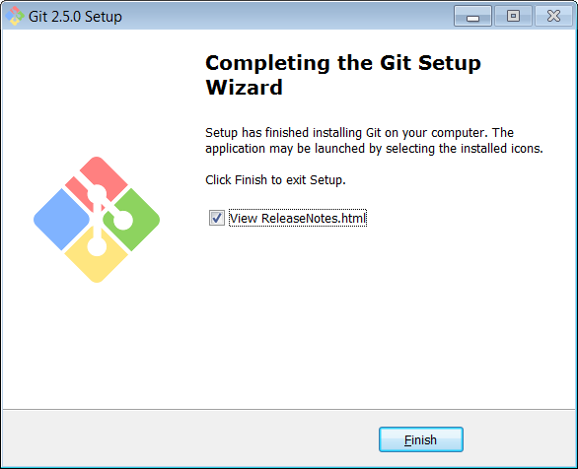

**Git LFS Installation**

1. Execute the software **git-lfs-windows-amd64-1.0.0.exe**
2. Accept Agreement

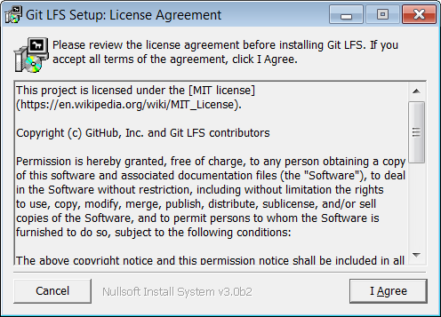

1. Leave Git LFS Setup Installation Folder as “C:\Program Files\Git\mingw64\bin” and click Install.

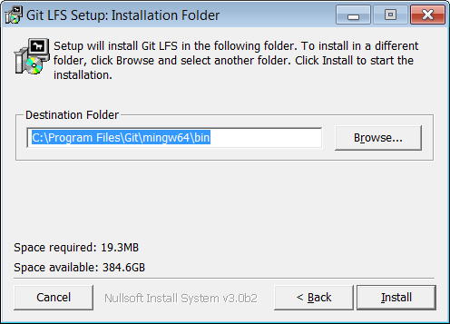

1. Git LFS Setup: Installation Completes.

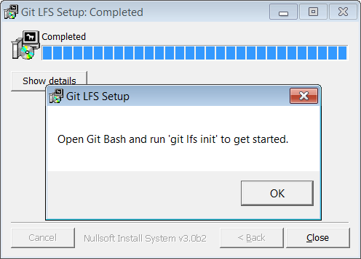

1. **Setting up SSLs for TortoiseGit**

Log off to the wksadmin account and Log back in as regular user and do not connect to VPN.

* 1. Goto Start Button 🡪 All Programs 🡪 TortoiseGit 🡪 PuTTYgen.
  2. To generate a public and private Key, Click on Generate and move the cursor over the blank area below the progress bar.
  3. Enter a Key passphrase and Confirm it.
  4. Click on Save public Key and Priavate Key buttons and save the files.

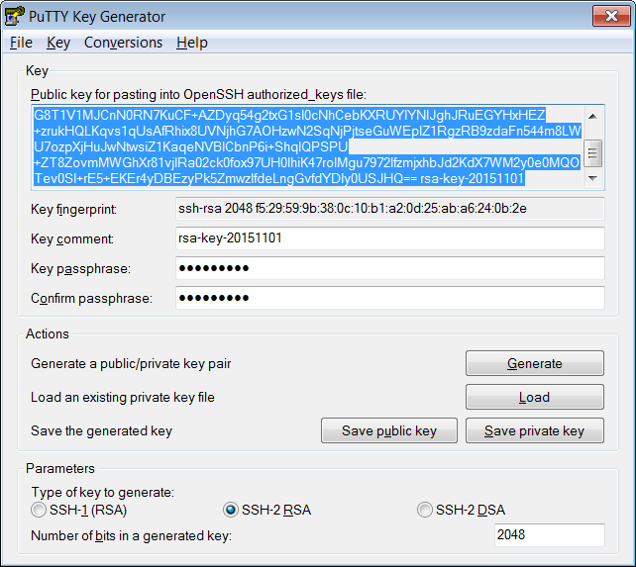

* 1. Set the Pubic Key in GitHub.com. Now login to GitHub.com and Under Settings 🡪 SSH Keys

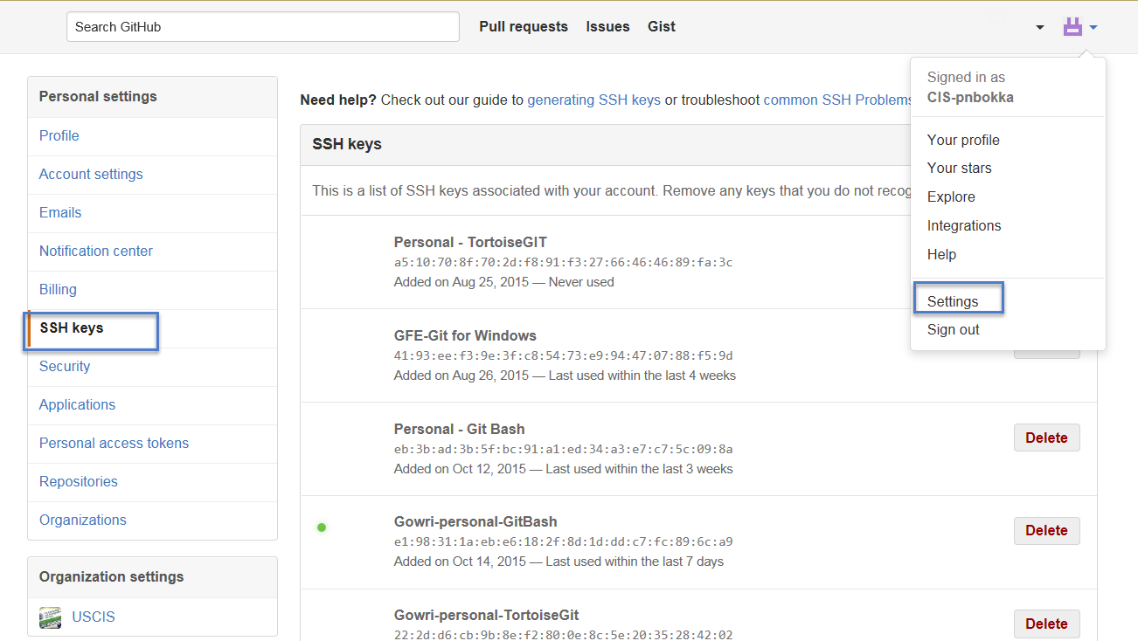

* 1. Click on Add SSH Key and Select the Public Key from PuTTYgen as shown in the previous screen and paste it here.

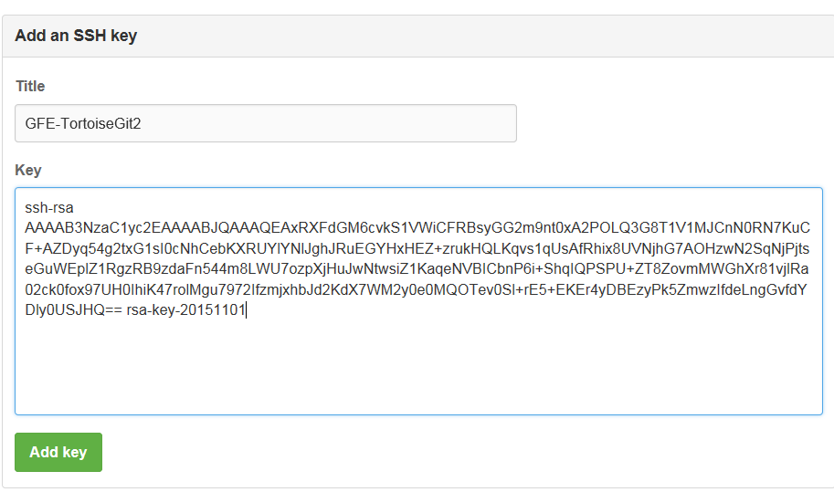

* 1. To set the private key, Click Start 🡪 All Programs 🡪 TortoiseGit 🡪 Pageant
  2. The Pageant will be running and is available in System Tray in the Bottom Right corner.

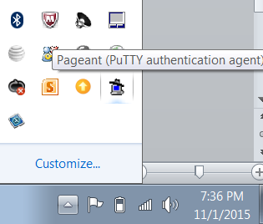

* 1. Right click on the Pageant icon and add the Private Key file saved from PuTTYgen. Need to enter the Passphrase entered while creating private key from PuttyGen.

Right Click on Pageant and view Keys should show the key in the list now.

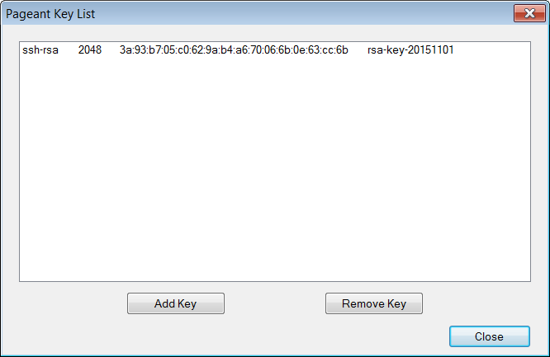

1. **TortoiseGit Configuration**
   1. Goto Start Button 🡪 All Programs 🡪 TortoiseGit 🡪 Settings
   2. Under Settings 🡪 click Git and set your Name and Email address as shown below.

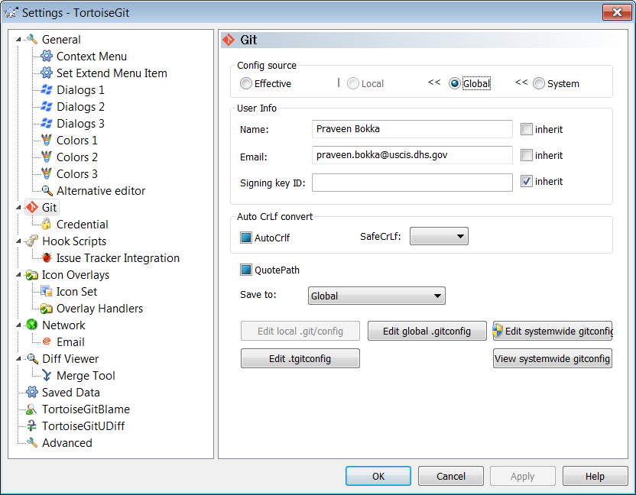

* 1. Now from GitHub.com, under repositories, select a repository you want to clone locally.

Copy the SSH URL from GitHub.com repository

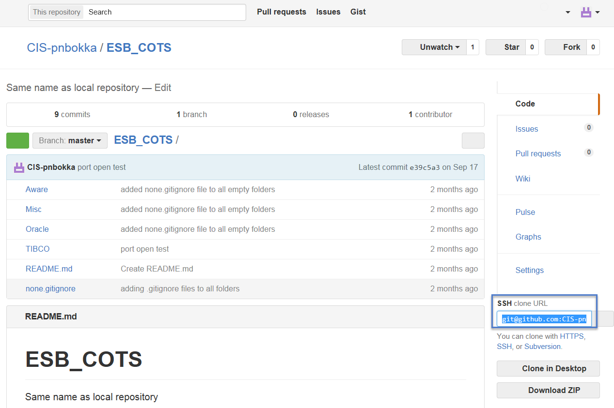

* 1. Under Tortoise Settings 🡪 Git 🡪 Credential

Select Advanced from Credential Drop down and Paste URL copied from previous step. Enter your username and Click Add New/Save button. Click Apply and OK.

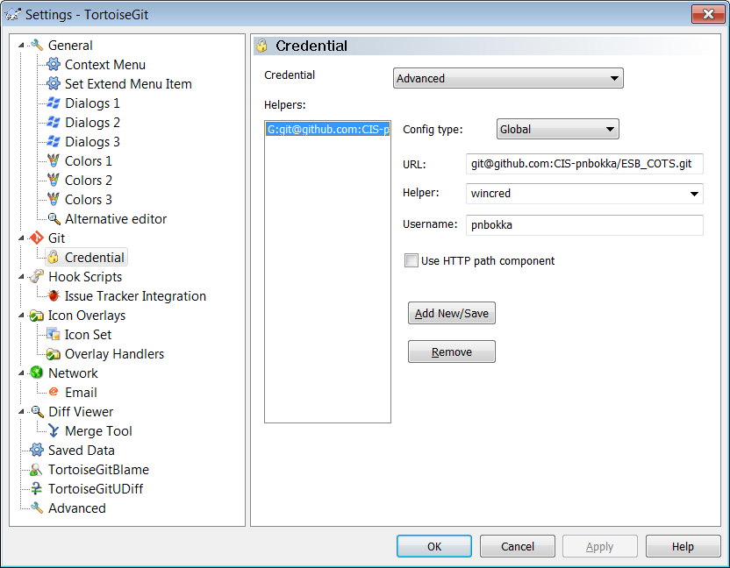

Setup is now complete.

**Cloning a Remote Repository Locally**

Open Explorer 🡪 Right click 🡪 Click Git Clone

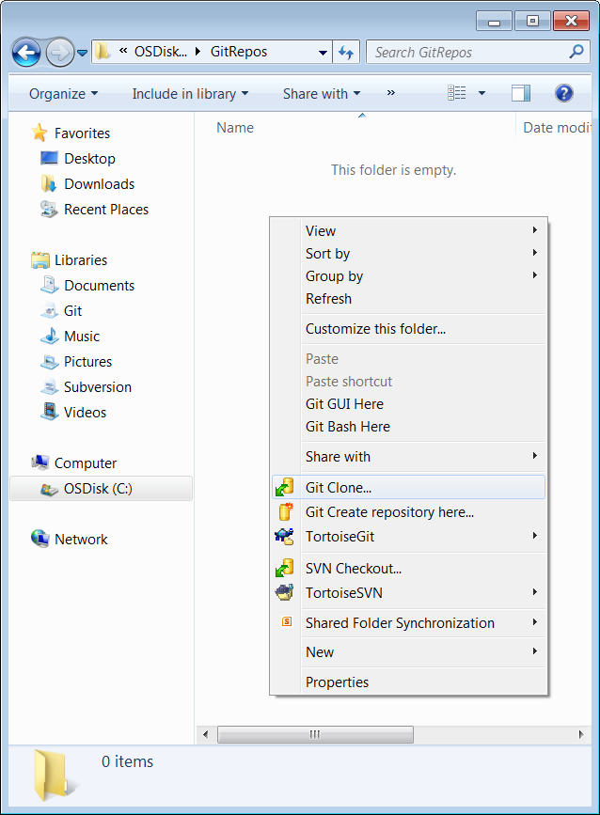

1. Copy SSH URL for GitHub repository to clone locally or use the default repository configured earlier.

Select Load Putty Key and Select the Private Key saved earlier.

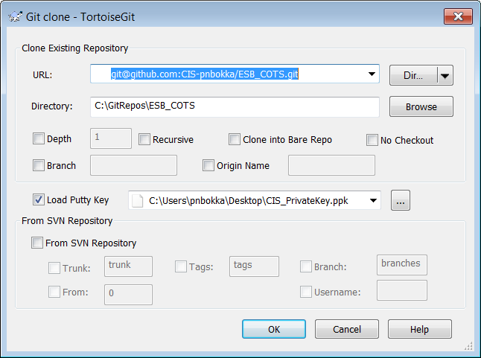

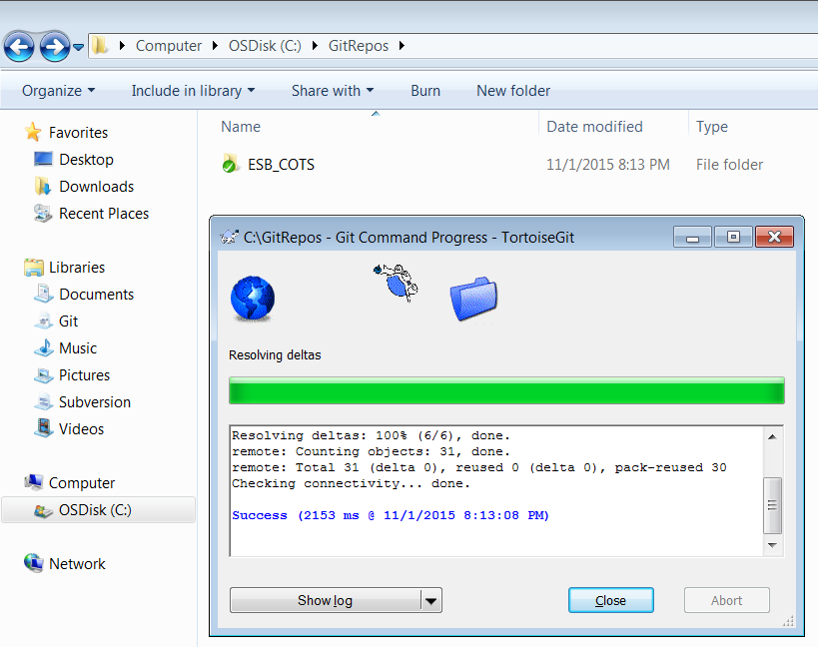

Cloning a remote repository locally is complete.

**Setting up Git for Windows (Git Bash)**

Please follow this link to setup Git Bash.

<https://help.github.com/articles/generating-ssh-keys/>

**Push and Pull Operations to Local and Remote repositories using TortoiseGit**

1. Adding a file to Git Hub

Add a file to the folder structure. To add the file to local repository

Right click on the file and TortoiseGit 🡪 Add

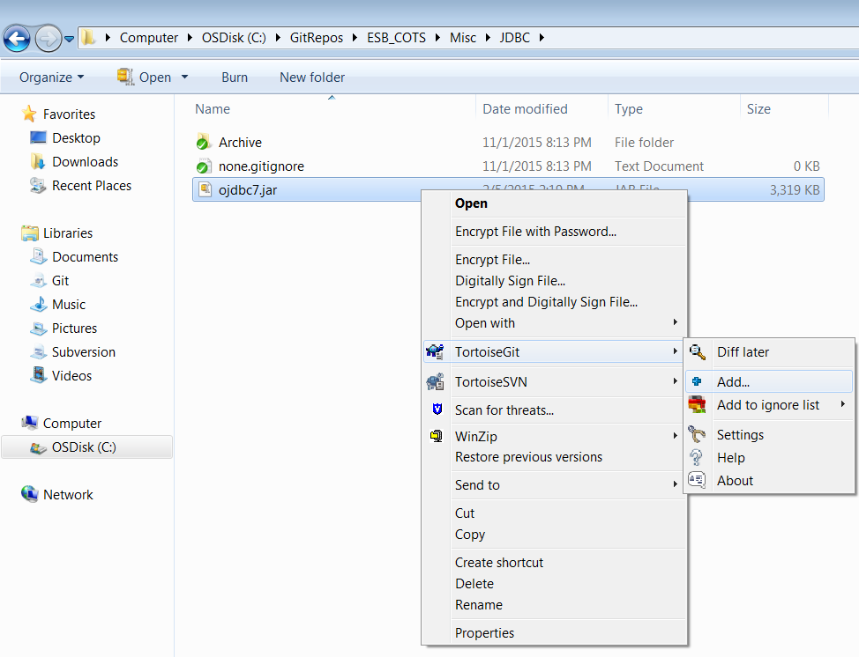

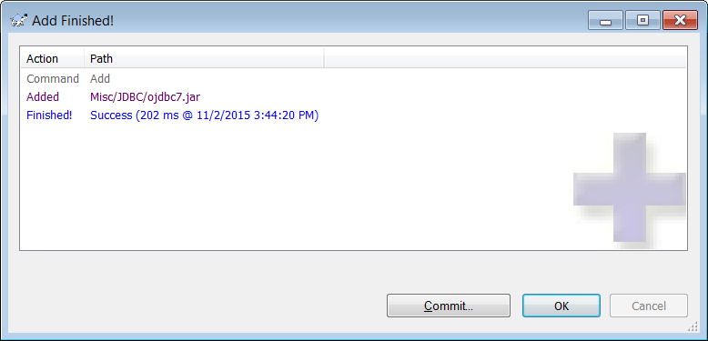

1. Commit the file to local repository using Git commit.

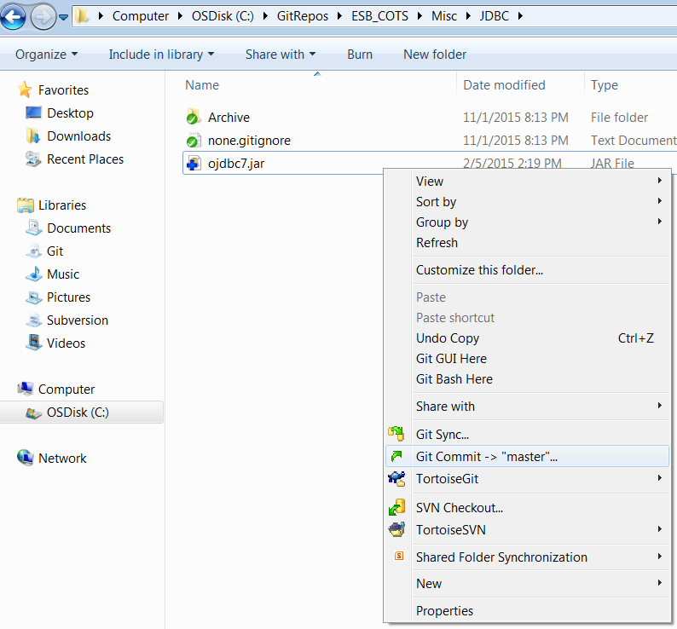

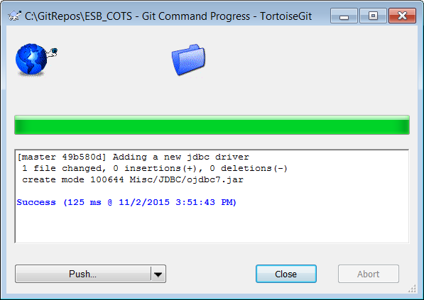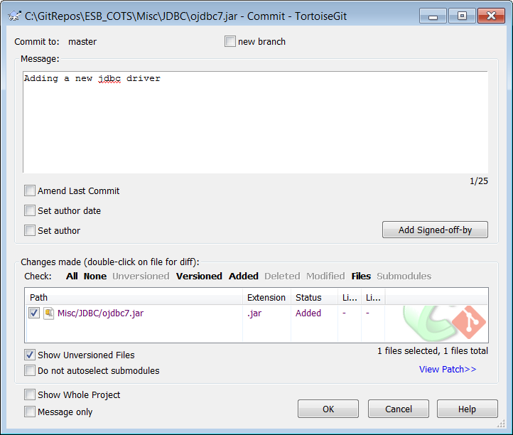

1. Sync the local repository with the Remote repository and push files to remote branch.

Right click on the local repository and in the dialog click **Git Sync** click Push button.

**Note:** **As Firewall is not open between GFE connected to VPN and GitHub.com, VPN needs to be disconnected before the Push/Pull/Git Clone operations.**

**But this step is not required when connecting to GitHub Test Environment and Git Hub Enterprise environments as they reside within the network.**

